Assignment 10

Joining Table to Itself.

1. Write a query that produces all pairs of salespeople who are living in the same city.Exclude combinations of salespeople with themselves as well as duplicate rows with the order reversed.

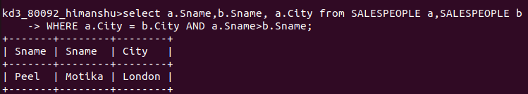

2. Write a query that produces the names and cities of all customers with the same rating as Hoffman.

